UNIT 5
Q1) Post Correspondence Problem (PCP)
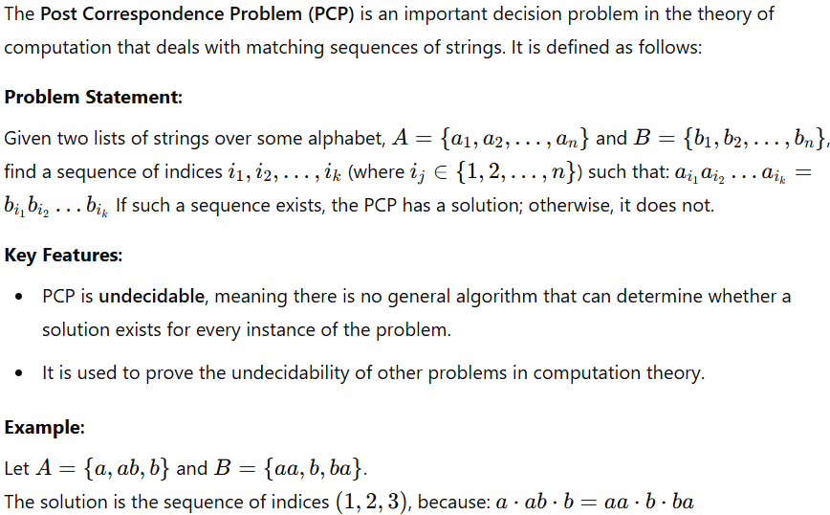
Q2) Differences between Pushdown Automata (PDA) and Turing Machine (TM)
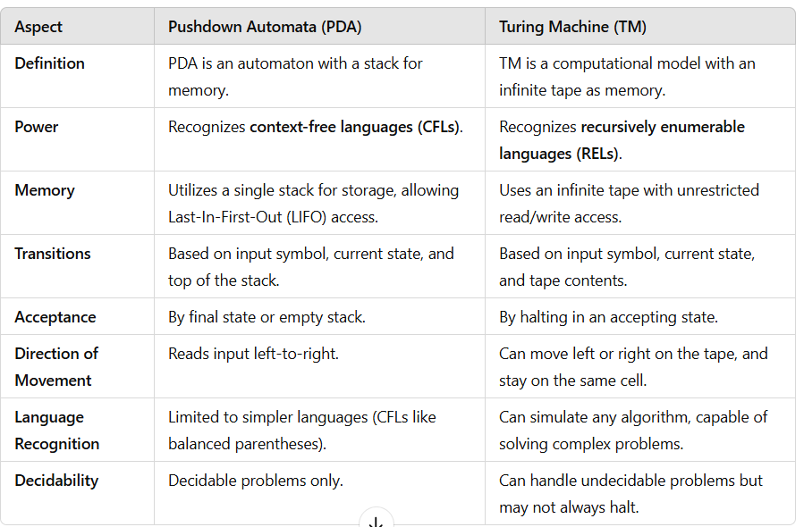
Q3) Variants of Turing Machine
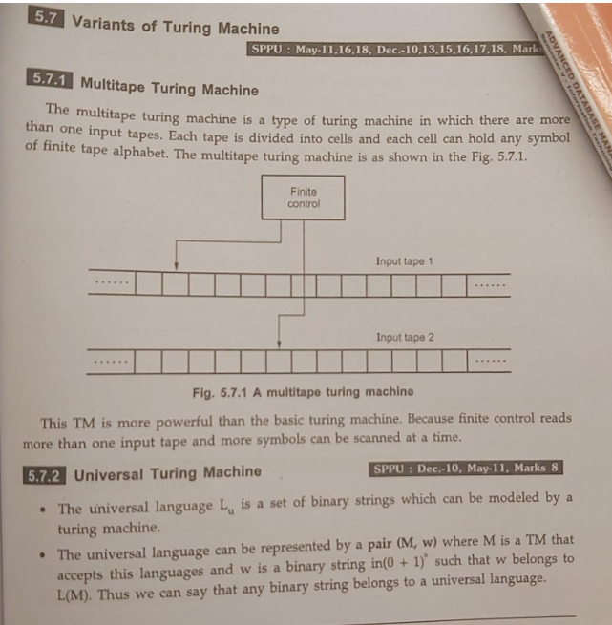
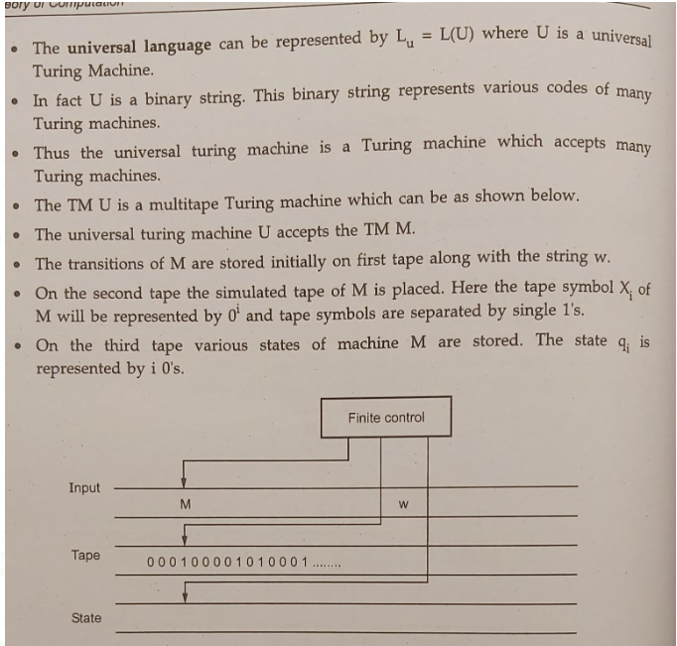
Q4) Church’s Turing thesis
Turing machine is defined as an abstract representation of a computing device such as hardware in computers. Alan Turing proposed Logical Computing Machines (LCMs), i.e. Turing’s expressions for Turing Machines. This was done to define algorithms properly. So, Church made a mechanical method named as ‘M’ for manipulation of strings by using logic and mathematics. This method M must pass the following statements:
- Number of instructions in M must be finite.
- Output should be produced after performing finite number of steps.
- It should not be imaginary, i.e. can be made in real life.
- It should not require any complex understanding.
Using these statements Church proposed a hypothesis called
that can be stated as: “The assumption that the intuitive notion of computable functions can be identified with partial recursive functions.”
Or in simple words we can say that “Every computation that can be carried out in the real world can be effectively performed by a Turing Machine.”
In 1930, this statement was first formulated by Alonzo Church and is usually referred to as Church’s thesis, or the Church-Turing thesis. However, this hypothesis cannot be proved. The recursive functions can be computable after taking following assumptions:
1. Each and every function must be computable.
2. Let ‘F’ be the computable function and after performing some elementary operations to ‘F’, it will transform a new function ‘G’ then this function ‘G’ automatically becomes the computable function.
3. If any functions that follow above two assumptions must be states as computable function.
------------------------------------------------------------------------------------------------------------------------------------------------Q5)Write short notes on i) Unsolvable problems ii) Applications of Turing Machine
i) Unsolvable Problems
Unsolvable problems are problems for which no algorithm or computational procedure can provide a solution for all possible inputs. These problems are fundamental to understanding the limits of computation.
Key Features:
- Definition: An unsolvable problem cannot be solved by any Turing Machine, meaning it is undecidable.
- Halting Problem: The most famous example, introduced by Alan Turing, asks whether a Turing Machine will halt on a given input. Turing proved that no algorithm can solve this problem for all inputs.
- Rice's Theorem: States that all non-trivial properties of the language recognized by a Turing Machine are undecidable.
- Examples:
  - Determining whether a Diophantine equation has a solution (Hilbert's 10th Problem).
  - Checking equivalence of two arbitrary programs.
Importance:
Unsolvable problems demonstrate the inherent limitations of computation and emphasize the need for approximations or heuristics in certain areas.
ii) Applications of Turing Machine
A Turing Machine (TM) is a theoretical computational model that plays a foundational role in computer science. Despite being abstract, it has significant applications:
Applications:
- Foundation of Computation Theory:
  - TM formalizes the concept of algorithms and serves as a benchmark for defining computable functions.
  - Helps distinguish between decidable and undecidable problems.
- Programming Language Design:
  - TMs influence the design of programming languages by modeling language constructs and control flows.
  - Serve as a theoretical framework for understanding compiler design.
- Artificial Intelligence and Machine Learning:
  - TM concepts guide the development of algorithms, especially those mimicking step-by-step human reasoning.
- Automata Theory and Formal Languages:
  - TM is used to define recursively enumerable languages.
  - Forms the basis for studying regular, context-free, and context-sensitive grammars.
- Cryptography:
  - Provides insights into problems like one-way functions and their relation to computational complexity.
- Complexity Theory:
  - TM is used to classify problems based on computational complexity classes (e.g., P, NP, NP-complete).
Example: A Universal Turing Machine simulates other Turing Machines, demonstrating the capability of general-purpose computation, analogous to modern programmable computers.
------------------------------------------------------------------------------------------------------------------------------------------------
q6) Recursive and Recursively Enumerable Languages
1. Recursive Languages (RLs):
Definition: A language LLL is recursive if there exists a Turing Machine (TM) that:
1. Halts on every input, regardless of whether the input is in the language.
2. Accepts the input if it belongs to the language LLL.
3. Rejects the input if it does not belong to LLL.
Key Characteristics:
The TM always produces a definite answer (accept or reject).
Recursive languages are also called decidable languages because a decision procedure exists for them.
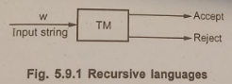
2. Recursively Enumerable Languages (RELs):
Definition: A language LLL is recursively enumerable if there exists a Turing Machine (TM) that:
1. Accepts the input if it belongs to the language LLL.
2. May run indefinitely if the input does not belong to LLL.
Key Characteristics:
The TM is not required to halt for inputs that are not in the language.
All recursive languages are also recursively enumerable, but the converse is not true.
RELs are also called semi-decidable languages because the TM provides an answer only for inputs in LLL.
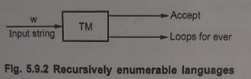
------------------------------------------------------------------------------------------------------------------------------------------------
q7)Halting Problem
